# Presentation – Vega-Lite in PBI and R

## Why use it?

1. Power
   1. Greater flexibility than any standard PBI visual
   2. Allows many more types of visuals than is possible in the standard library
   3. Allows layering visuals on top of each other, next to each other, and faceting (to squeeze in that extra dimension)
2. Collaboration
   1. Code is portable. You can copy and paste from other reports and online examples.
3. Cross-platform
   1. The exact same visual can be replicated across Power BI, R, Python etc….just copy and paste.
4. Security – Microsoft PBI Certified means Microsoft has reviewed source code & approved.

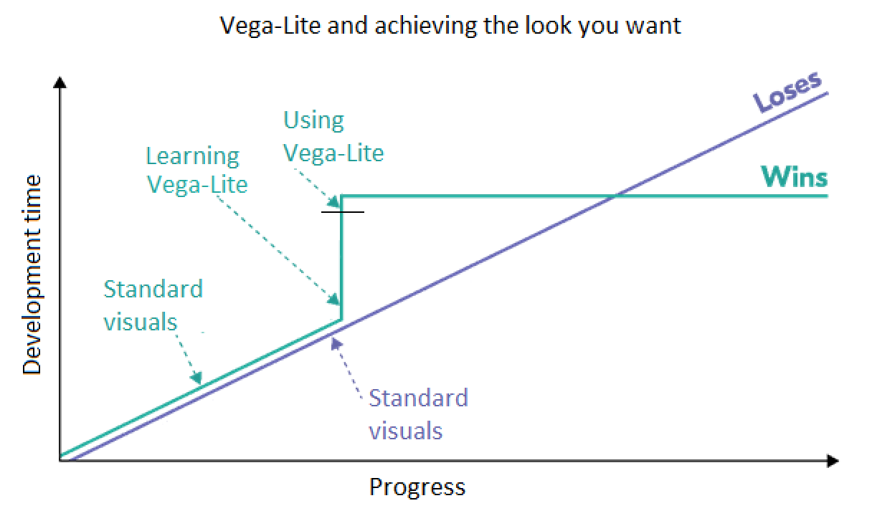

## Example galleries

Any of the code used to produce these excellent graphs can be copied and tweaked to suit your report needs.

* [Vega-Lite examples](https://vega.github.io/vega-lite/examples/)
* [Jack’s custom Vega-Lite efforts](https://github.com/jack-bryde/Deneb-Templates)
* [Vega examples](https://vega.github.io/vega/)
* [David Bacci](https://github.com/PBI-David/Deneb-Showcase)
* [Kerry Kolosko](https://kerrykolosko.com/portfolio-category/deneb-templates/)

## What is it?

* Vega and Vega-Lite are JSON text files that contain all of your chart options such as chart type, legend, axis etc.
* JSON is a format for nested key:value pairs, where each value can *itself* be a set of key:value pairs. Basically, Inception for computers. This is a common file structure for JavaScript, and Vega relies on the d3.js graphics library (which is very powerful).

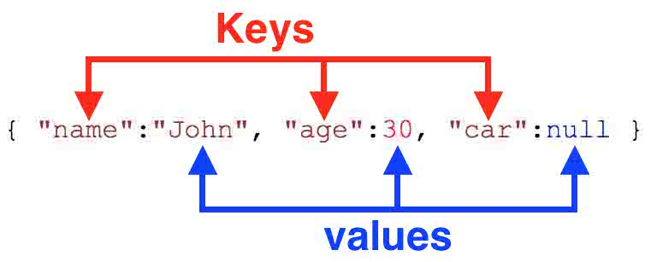

* In Power BI, this JSON file is created in the Deneb custom visual available from App Source. Deneb also runs the conversion of Vega file spec to JavaScript.
* Basic structure of the Vega-Lite spec:
* **Data** (restricted in Power BI to just “dataset” determined by fields in the Values well)
* **Transform** (you can create measures *within* Vega-Lite - usually this is just for filtering)
* **Mark** (type of chart – bar, map, etc)
* **Encoding** (which columns should be on the y and x axis)
* **Others** (don’t worry about the rest)

## Example – Population Pyramid

* Power BI funnel chart is terrible – no ability to colour by Gender, and Y axis values are always on the left. Let’s build a population pyramid that colours by Gender. Then we’ll swap Gender for another field and see how easy it is.
* This only took about 1 or 2 hours to develop, because I simply copied the code from [this example](https://vega.github.io/vega-lite/examples/concat_population_pyramid.html) and tweaked it to this dataset.
* Using the ERP for 2023 by ABS (here), a publicly available dataset.
* This uses the “*hconcat*” option in Vega-Lite to combine (concatenate) three different charts horizontally: Women, Age Group Labels, and Men. For each chart, we have the following basic properties:
* **Data:** dataset
* **Transform**: filters data by Gender (left and right charts only).
* **Mark:** horizontal bar charts. Tooltip options are added here.
* **Encoding:** X axis is sum of Population, Y axis is Age Group.
* Note: how tooltip affects the first category (Women), but not the others. That’s because it wasn’t
* Note: hit ‘Apply changes’ often.
* Note: Power BI does not allow visuals to resize themselves dynamically, so if you wish to change the physical width and/or height of your visual in the report view, you will need to exit the advanced editor, resize and re-open the advanced editor.